**Environmental Science**

Kimberly Balcera

Justin Cijntje

Kervens Mallebranche

Roodnely Ulysse

Arduino Soil 04: Surface temperature.

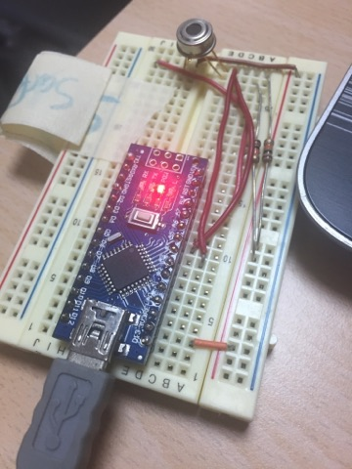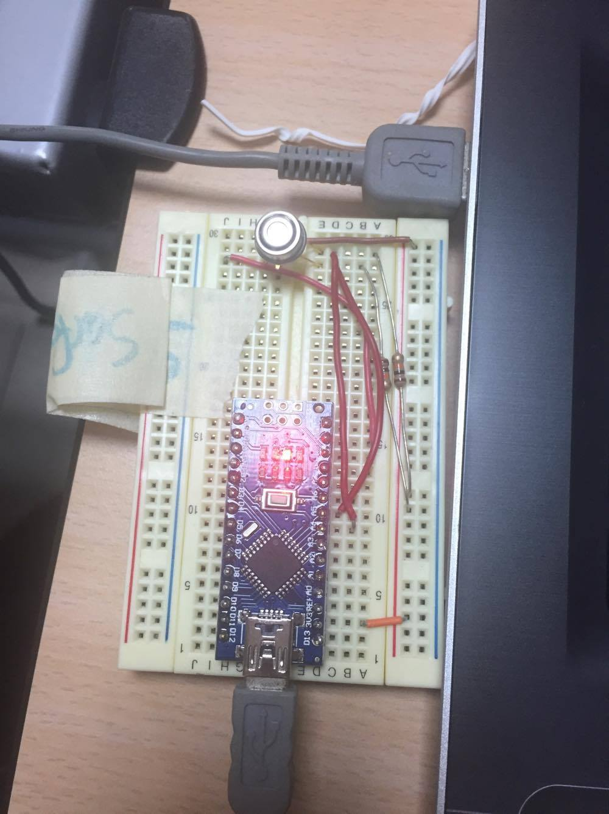

Aruba has an average daytime temperature of 27°C (82°F).

This sensor measures infrared light bouncing off remote objects, so it can measure temperature without having to touch them physically. Point the sensor towards what you want to measure, by doing so it will detect temperature by absorbing infrared waves emitted.

It is important to measure surface temperature, so we can see the change in temperature trends to conclude if global warming is real or not.

We measured the temperature in different locations at the University of Aruba to know the levels of the heat in certain areas.

The average sensor temperature is from -70°C to +380°C.

The values at the UA:

**Classroom**

Classroom ground temperature:

Ambient = 24.51*C Object = 24.75*C

Ambient = 76.12*F Object = 76.55*F

Classroom temperature:

Ambient = 22.47*C Object = 25.53*F

Ambient = 72.45*C Object = 77.95*F

**Outside under the shade**

Ground temp.:

Ambient = 33.55*C Object = 34.25*C

Ambient = 92.39*F Object = 93.65*F

Under the shade temp.:

Ambient = 32.55*C Object = 31.77*C

Ambient = 90.50*F Object = 89.19*F

**Under the sun**

Outside ground temp.:

Ambient = 37.25*C Object = 41.77*C

Ambient = 99.05*F Object = 107.19*F

Under the sun temp.:

Ambient = 36.89*C Object = 25.93*C

Ambient = 98.40*F Object = 78.67*F

**On the road**

Asphalt temp:

Ambient = 37.03*C Object = 49.49*C

Ambient = 98.65*F Object = 121.08*F

Road temp:

Ambient = 38.71*C Object = 23.53*C

Ambient = 101.68*F Object = 74.35*F

**CODE:**

**soil04_SurfaceTemperature.ino**

/***************************************************

This is a library example for the MLX90614 Temp Sensor

Designed specifically to work with the MLX90614 sensors in the

adafruit shop

----> https://www.adafruit.com/products/1748

----> https://www.adafruit.com/products/1749

These sensors use I2C to communicate, 2 pins are required to

interface

Adafruit invests time and resources providing this open source code,

please support Adafruit and open-source hardware by purchasing

products from Adafruit!

Written by Limor Fried/Ladyada for Adafruit Industries.

BSD license, all text above must be included in any redistribution

****************************************************/

#include <Wire.h>

#include <Adafruit_MLX90614.h>

Adafruit_MLX90614 mlx = Adafruit_MLX90614();

void setup() {

Serial.begin(9600);

Serial.println("Adafruit MLX90614 test");

mlx.begin();

}

void loop() {

Serial.print("Ambient = "); Serial.print(mlx.readAmbientTempC());

Serial.print("*C\tObject = "); Serial.print(mlx.readObjectTempC()); Serial.println("*C");

Serial.print("Ambient = "); Serial.print(mlx.readAmbientTempF());

Serial.print("*F\tObject = "); Serial.print(mlx.readObjectTempF()); Serial.println("*F");

Serial.println();

delay(500);

}